Nicolas Gonzalez

May 29, 2023

CIS233DA 17130

Professor McHardy

Resource Setup

GitHub URL: <https://github.com/qub-e/CIS233DA>

Folders:

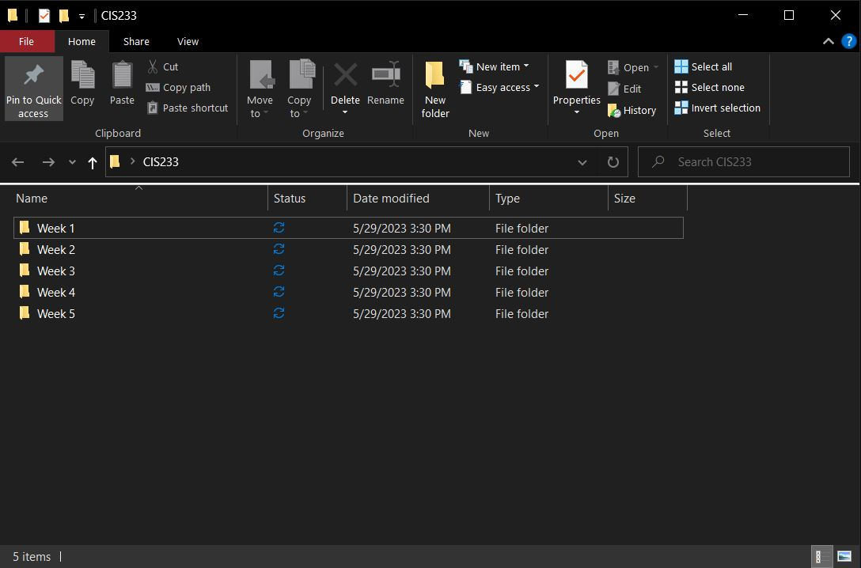

VS Code:

